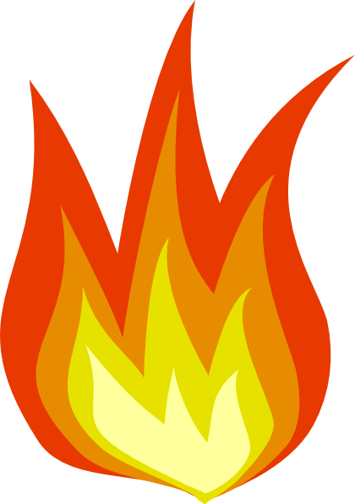**Fire Safety Study**

What would you do if you were stuck in a building in fire? What would you do if you smelt smoke? **We want to know!**

If you are 18 or older, and live or lived in an OSU dormitory, please contact our research group at [felix@oregonstate.edu](mailto:felix@oregonstate.edu) to setup a **30 minutes interview**.

This interview aims at discovering what you would do to maintain your own safety in various fire-related situations.

**Your time will be compensated with** **$10** AND the results of this study might help save a life!